- 字體很難閱讀-可以換字體
- 不用提到Etsy,之後直接會用這個網站，不用提到他
- 後台操作看可不可以做簡單明瞭，馬上就可以操作的樣子

About-part
- 可以像這樣，給我一個標題、附文，和圖片區域
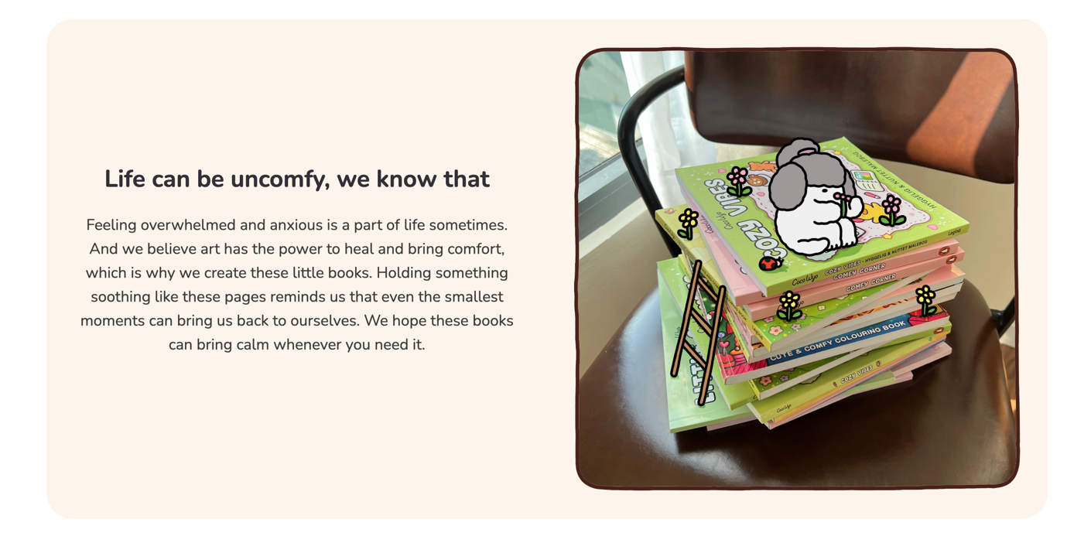
Home-part
我覺得可以完全照抄Coco wyo的主頁
https://cocowyo.com/

Products-part
下拉選單包含：Digital page, Digital greeting card,Physical books,

Gallery-part
我可以上傳別人和我畫的圖的照片，滑到的時候可以像這樣顯示
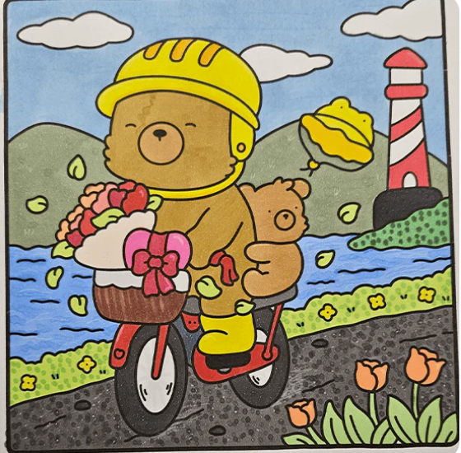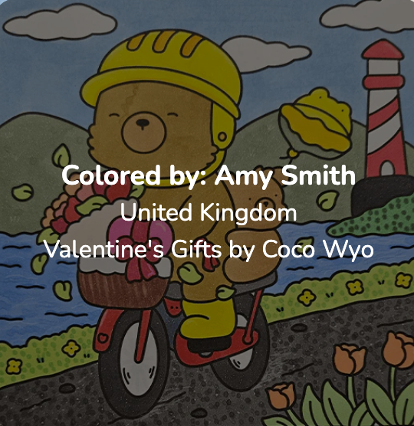

Free Pack- part
可以完全照抄這個
https://cocowyo.com/pages/freebies

Q&A-part
Q1: Where can I buy Zoe & Book physical coloring books?
A: Amazon: Available on Amazon in the US, UK, Canada, Australia, Germany, France, Italy, and more. Availability depends on the official Amazon marketplace in your country.
Q2: Is the book appropriate for beginners or experts?
A: Our books are made for everyone - whether you're a beginner just starting your coloring journey or an experienced colorist looking for a moment of creative freedom. We offer a variety of styles, from quick and stress-free designs to highly detailed illustrations that will keep you engaged for hours. No matter your skill level, just grab your colors and enjoy
Q3: What coloring tools should I use for coloring books?
A: Colored pencils, gel pens, and Crayola work perfectly! For wet mediums like alcohol-based or water-based markers, place an extra sheet underneath the coloring page to prevent bleed-through to the next page.

Q4: How can I prevent color from bleeding through the pages?
A: Use a protective sheet like cardstock, a plastic sheet, or even just an extra piece of paper under your coloring page to keep the next page safe.

Q5: What is the return or exchange policy?
A:
- Amazon: Returns are allowed for defective or damaged books.
- Etsy: Since digital books are instant downloads, they’re non-refundable. If you have any issues, feel free to reach out!

Q6: What should I do if I receive a defective book?
- A: Check if the issue is due to printing or shipping damage.
- Contact the platform where you purchased the book (Amazon, etc.) for support.

Q7: Where can I share my finished coloring pages?
A: We’d love to see your artwork!
Instagram @zoenbook_coloring and don’t forget to tag #zoenbook #zoenbookcoloring

Final

We’re always happy to help make your experience as smooth and enjoyable as possible. Feel free to reach out to us!
(這邊有沒有要做一個可以回覆訊息的地方，你覺得呢？還是辦一個新的email)

